Agile Development ([Standish Article](https://www.infoq.com/articles/standish-chaos-2015))

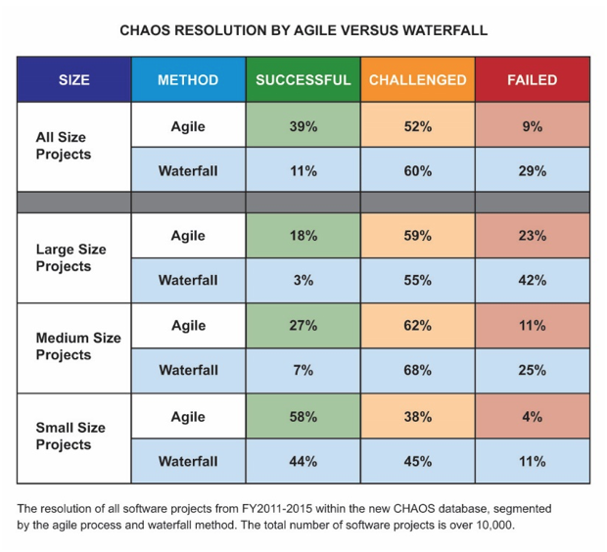

Size + Complexity multiply the chances of failure

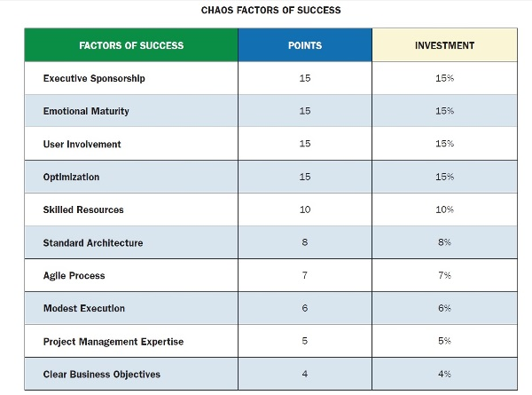

**Executive Support:** when an executive or group of executives agrees to provide both financial and emotional backing. The executive or executives will encourage and assist in the successful completion of the project.

**Emotional maturity:** is the collection of basic behaviors of how people work together. In any group, organization, or company it is both the sum of their skills and the weakest link that determine the level of emotional maturity.

**User Involvement:** takes place when users are involved in the project decision-making and information-gathering process. This also includes user feedback, requirements review, basic research, prototyping, and other consensus-building tools.

**Optimization:** is a structured means of improving business effectiveness and optimizing a collection of many small projects or major requirements. Optimization starts with managing scope based on relative business value.

**Skilled Resources:** are people who understand both the business and the technology. A skilled staff is highly proficient in the execution of the project’s requirements and deliver of the project or product.

**Standard Architecture (SAME):** is Standard Architectural Management Environment. The Standish Group defines SAME as a consistent group of integrated practices, services, and products for developing, implementing, and operating software applications.

**Agile proficiency:** means that the agile team and the product owner are skilled in the agile process. Agile proficiency is the difference between good agile outcomes and bad agile outcomes.

**Modest execution:** is having a process with few moving parts, and those parts are automated and streamlined. Modest execution also means using project management tools sparingly and only a very few features.

**Project management expertise:** is the application of knowledge, skills, and techniques to project activities in order to meet or exceed stakeholder expectations and produce value for the organization.

**Clear Business Objectives:** is the understanding of all stakeholders and participants in the business purpose for executing the project. Clear Business Objectives could also mean the project is aligning to the organization’s goals and strategy.

Agile Team Components (Scrum)

[Scrum guide](https://www.scrumguides.org/scrum-guide.html)

*The Product Owner*

The Product Owner is the project’s key stakeholder – usually an internal or external customer, or a spokesperson for the customer. There is only one Product Owner who conveys the overall mission and vision of the product which the team is building. The Product Owner is ultimately accountable for managing the product backlog and accepting completed increments of work.

*The ScrumMaster*

The ScrumMaster is the servant leader to the Product Owner, Development Team and Organization. With no hierarchial authority over the team but rather more of a facilitator, the ScrumMaster ensures that the team adheres to Scrum theory, practices, and rules. The ScrumMaster protects the team by doing anything possible to help the team perform at the highest level. This may include removing impediments, facilitating meetings, and helping the Product Owner groom the backlog.

*The Development Team*

The Development Team is a self-organizing, cross-functional group armed with all of the skills to deliver shippable increments at the completion of each sprint. Scrum broadens the definition of the term “developer” beyond programmers to include anyone who participates in the creation of the delivered increment. There are no titles in the Development Team and no one, including the ScrumMaster, tells the Development Team how to turn product backlog items into potentially shippable increments

Scrum Events (Ceremonies)

*The Sprint*

A sprint is a time-boxed period during which specific work is completed and made ready for review. Sprints are usually 2-4 weeks long but can be as short as one week.

*Sprint Planning*

Sprint Planning team meetings are time-boxed events that determine which product backlog items will be delivered and how the work will be achieved.

*The Daily Stand-up*

The Daily Stand-up is a short communication meeting (no more than 15 minutes) in which each team member quickly and transparently covers progress since the last stand-up, planned work before the next meeting, and any impediments that may be blocking his or her progress.

*The Sprint Review*

The Sprint Review is the “show-and-tell” or demonstration event for the team to present the work completed during the sprint. The Product Owner checks the work against pre-defined acceptance criteria and either accepts or rejects the work. The stakeholders or clients give feedback to ensure that the delivered increment met the business need.

*The Retrospective*

The Retrospective, or Retro, is the final team meeting in the Sprint to determine what went well, what didn’t go well, and how the team can improve in the next Sprint. Attended by the team and the ScrumMaster, the Retrospective is an important opportunity for the team to focus on its overall performance and identify strategies for continuous improvement on its processes.

Scrum Artifacts

*Product Backlog*

The product backlog is the single most important document that outlines every requirement for a system, project or product. The product backlog can be thought of as a to-do list consisting of work items, each of which produces a deliverable with business value. Backlog items are ordered in terms of business value by the Product Owner.

*Sprint Backlog*

A sprint backlog is the specific list of items taken from the product backlog which are to be completed in a sprint.

*Increment*

An Increment is the sum of all product backlog items that have been completed since the last software release. While it is up to the Product Owner to decide on when an increment is released, it is the team’s responsibility to make sure everything that is included in an increment is ready to be released. This is also referred to as the Potentially Shippable Increment (PSI).